Ted Brown April 9, 2017

Well, I didn’t expect to see another CD release at this point in my life but I am happy to announce that a new one is now available.

This is with the rhythm section of Jon Easton-piano, Don Messina-bass and Bill Chattin-drums. We have played many sessions together at Sal Mosca’s studio as well as summer gigs at Trumpets Jazz Club in Montclair, NJ. And it always feels great.

The first five tunes are from August, 2006 and the last four are from August, 2010 at Trumpets. Don Messina recorded everything while he was playing and did all the leg work in getting this project mastered, the art work, and coordination with Bob Rusch at Cadence Jazz Records.

It is difficult for me to get to the Post Office so if you are interested in buying one please contact Don below and he will keep me up to date on that. Thank you very much…Ted Brown

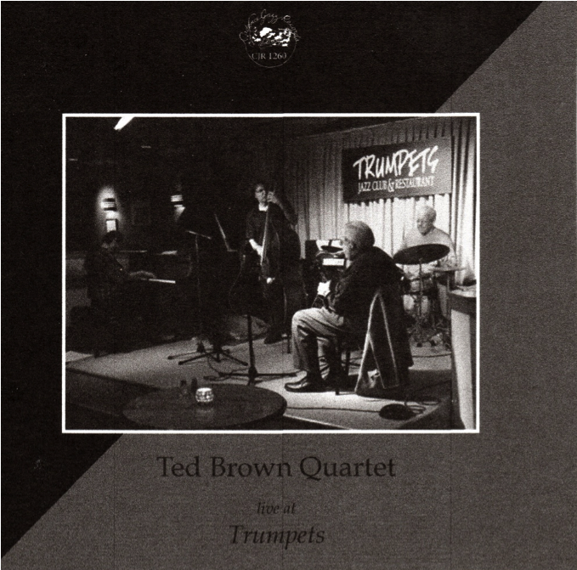

Don Messina
2522 Tack Circle
Scotch Plains, NJ 07076
Email: dmessina2522@comcast.net

Price: $15.00 + 2.50 shipping and handling
Please make checks payable to Don Messina

International sales: Email to orders@cadencebuilding.com

